TABLE OF CONTENTS
1. Rationale 3
1.1 Problem Description 3
1.2 Background 3
1.3 Community Impact 3
1.4 Proposed Solution 3
1.5 Computational Thinking Process 4
1.6 Algorithm Design 4
1.7 SDG Alignment 4
1.8 Open Source Justification 4
1.9 Digital Public Goods Justification 4
2. Algorithm (Step by Step) 5
3. Pseudocode 6
4. Flowcharts 10
4.1 Main System Flowchart 10
4.2 Submit Report and Validation 11
4.3 Classify Priority 12
4.4 Process Reports and Dispatch Trucks 13
4.5 Daily Summary 14
5. Functional Modules 15
5.1 Constants 15
5.2 Variables and Data Types 16
5.3 Programming Logic Coverage 16
6. Expected Outputs 17
6.1 Sample Console Output 17
7. GitHub Evidence 18
7.1 Commit History 18
7.2 Repository File Structure 18
7.3 Rendered README.md 19
8. References 20
Appendix A: README.md (Repository Front Page) 21
Project Overview 21
Sustainable Development Goals 21
Open Source and Digital Public Good 21
Repository Contents 21
System Modules 21
Priority Rules (summary) 22

1. Rationale

1.1 Problem Description
Many communities in Sierra Leone, especially densely populated urban areas such as Freetown, struggle with unmanaged household and market waste. Bins and dumping points overflow, waste is left beside drains and streams, and residents have no simple way to tell collection teams where and when waste has built up. Collection is often irregular and not based on need, so some places are visited when they are nearly empty while others stay full for days. The people affected are residents of informal and low-income settlements, market traders, school and clinic staff, collection workers and the local councils responsible for sanitation.
The problem exists because of several connected factors: limited collection trucks and fuel, no central record of which areas are full, no structured way for citizens to report, rapid urban growth and low awareness of waste separation. The proposed solution, CleanSalone, is a logical design for a reporting and dispatch system. Citizens or community volunteers report a full bin or dump, the system validates the report, assigns a priority and sends the nearest available truck to the most urgent places first.

1.2 Background
Poor waste management links directly to public health and disaster risk. According to ACAPS (2017), only about 40% of Freetown's waste reaches formal disposal sites, and the rest is burned at home or dumped in waterways, drainage channels, alongside roads and on vacant land, while many low-lying settlements already have poor drainage. A GSMA (n.d.) case study reports that Freetown produces about 550 tonnes of solid waste per day, that only about 30% is collected and that more than 300 tonnes per day is buried, burned or dumped in waterways or drains. These conditions raise the risk of flooding and waterborne disease: the same ACAPS note, written after the August 2017 Regent mudslide and floods that killed at least 400 people in the first days, warns of a high risk of waterborne disease and states that cholera is endemic in Sierra Leone. At the same time, Freetown already uses a mobile platform, DortiBox, for registration, pickup scheduling and mobile-money payment (GSMA, n.d.), which makes simple reporting through SMS, USSD or a basic app realistic. Before any software is written, a Junior System Analyst must first understand the problem and design the logic. This assignment therefore concentrates on analysis and logical design, not on source code.

1.3 Community Impact
- Problem being solved: irregular, unprioritised and unreported waste collection.
- Expected impact: faster response to overflowing bins, fewer blocked drains, cleaner public spaces and better use of limited trucks and fuel.
- Beneficiaries: residents, market traders, schools, clinics, collection workers and the city council.
- Long-term sustainability: the system is cheap to run, uses open tools, can be maintained by local developers and students, and builds a data history that councils can use for budgeting and planning.

1.4 Proposed Solution
CleanSalone is built from seven modules: main menu, submit report, validate report, classify priority, process reports and dispatch trucks, check report status and daily summary. A report contains the community name, zone, waste type, bin fill level (0 to 100 percent), days since last collection and whether the waste is next to a drain. The system rejects invalid input, classifies the report as CRITICAL, HIGH, MEDIUM or LOW, sorts the queue by priority and assigns an available truck in the same zone. If no truck is free, the supervisor is notified. A daily summary shows totals for the council.

1.5 Computational Thinking Process
Decomposition: the large problem of "waste collection" is split into smaller problems: reporting, checking, ranking, dispatching, tracking and summarising. Each becomes a function or module.
Pattern recognition: every report has the same fields and every report goes through the same path (validate, classify, queue, dispatch). Overflowing bins near drains and hazardous waste follow the same urgent pattern.
Abstraction: the design ignores details that do not affect decisions, such as bin colour or street names, and keeps only fill level, waste type, days since collection, drain proximity and zone.
Algorithm design: the steps are written as an ordered algorithm, then as pseudocode and flowcharts so that any developer can implement them in any language.

1.6 Algorithm Design
The algorithm uses input, processing and output. Input: report details and menu choices. Processing: validation with decision structures, priority classification with Boolean logic, sorting and a repetition structure that loops through the report queue and the truck list. Output: confirmation messages, truck assignment notices, status information and the daily summary. The full step-by-step algorithm is in Section 2 and the pseudocode in Section 3.

1.7 SDG Alignment
- SDG 11: Sustainable Cities and Communities (primary). Target 11.6 aims to reduce the environmental impact of cities, with special attention to waste management. CleanSalone makes municipal collection more responsive and organised.
- SDG 3: Good Health and Well-being. Prompt removal of hazardous and overflowing waste reduces disease risk.
- SDG 13: Climate Action. Keeping drains clear reduces flood risk, and efficient dispatch reduces unnecessary truck trips and fuel use.

1.8 Open Source Justification
CleanSalone should be open source because public sanitation is a shared responsibility and councils in Sierra Leone have limited budgets. Open source means there are no licence fees, the logic can be inspected and trusted, and local students and developers can adapt it to Bo, Kenema, Makeni or Koidu without asking permission. Benefits for Sierra Leone include lower costs, local skills development, transparency, no dependence on one vendor and the freedom to translate it into Krio, Mende and Temne. Community contributions could include translations, SMS and USSD gateways, bug fixes, better priority rules, mapping of collection points and documentation. Using Git and GitHub supports this by recording every change and allowing contributors to propose improvements through pull requests.

1.9 Digital Public Goods Justification
A Digital Public Good (DPG) is open-source software, open data or open content that follows privacy and other best practices and helps achieve the SDGs. CleanSalone could qualify by publishing its design and code under an open licence such as MIT or Apache 2.0, documenting it clearly, protecting personal data (only a community name and zone are required) and publishing anonymised waste statistics as open data. It promotes accessibility because it can work through basic phones and simple interfaces, openness because anyone can reuse it, and public benefit because the outcome is a cleaner, healthier community available to all.

2. Algorithm (Step by Step)
The following numbered algorithm describes how CleanSalone operates from start to finish.
- START the program. Initialise an empty report queue and load the truck list. Define constants (FULL_THRESHOLD = 80, CRITICAL_FILL = 90, MEDIUM_FILL = 50, URGENT_DAYS = 5, OVERFLOW_DAYS = 3, TRUCK_CAPACITY = 10).
- Display the main menu: 1 Submit report, 2 Process reports, 3 Check report status, 4 Daily summary, 5 Exit. Read the choice.
- If the choice is 1, read the report details: community name, zone, waste type, fill level, days since last collection, near drain (Yes/No).
- Validate the report. If the name is empty, the waste type is unknown, the fill level is outside 0 to 100 or the days are negative, show an error, reject the report and return to the menu.
- Classify priority. If the waste is hazardous, OR the bin is 90% or more full for 3 or more days, OR the waste is near a drain and at least 50% full, the priority is CRITICAL. Otherwise, if fill is 80% or more OR days since collection are 5 or more, the priority is HIGH. Otherwise, if fill is 50% or more, MEDIUM. Otherwise, LOW.
- Create the report with a unique ID and status PENDING. Add it to the queue and show the ID and priority to the user.
- If the choice is 2, check whether the queue is empty. If yes, show "No pending reports".
- Otherwise sort the queue so that CRITICAL reports come first and LOW last.
- REPEAT for each report in the queue: if its status is PENDING, search the truck list for a truck in the same zone that is available and has spare capacity.
- If a truck is found, assign it: set the report to ASSIGNED, increase the truck load by 1, mark the truck unavailable if it reaches capacity and notify the community. If no truck is found, notify the supervisor.
- If the choice is 3, read a report ID, search the queue and show the community, priority and status, or "Report not found".
- If the choice is 4, REPEAT through all reports and count total, critical, assigned and pending reports, then display the summary.
- If the choice is 5, display a goodbye message and STOP. For any other value, show "Invalid choice" and return to step 2.

3. Pseudocode
The pseudocode below follows the algorithm and is also provided as pseudocode.txt in the GitHub repository. Constants are written in capitals, variables in camelCase and every module is a named function.
CLEANSALONE - COMMUNITY WASTE COLLECTION AND REPORTING SYSTEM
PSEUDOCODE (PROG101 Assignment 1)

CONSTANTS
CONSTANT FULL_THRESHOLD = 80 // % fill at which a bin is "full"
CONSTANT CRITICAL_FILL = 90 // % fill treated as overflowing
CONSTANT MEDIUM_FILL = 50
CONSTANT URGENT_DAYS = 5 // days without collection = urgent
CONSTANT OVERFLOW_DAYS = 3
CONSTANT MAX_FILL = 100
CONSTANT MIN_FILL = 0
CONSTANT TRUCK_CAPACITY = 10 // collection points per truck per day
CONSTANT VALID_WASTE = ["GENERAL", "PLASTIC", "ORGANIC", "HAZARDOUS"]

VARIABLES AND DATA TYPES
reportID : Integer
communityName : String
zone : String // e.g. "WEST-1"
wasteType : String
fillLevel : Integer // 0 - 100 (%)
daysSinceLast : Integer
nearDrain : Boolean // bin or heap beside a drain/waterway
isValid : Boolean
priority : String // CRITICAL / HIGH / MEDIUM / LOW
reportQueue : List of Report
truckList : List of Truck // id (String), zone (String), load (Integer), available (Boolean)
choice : Integer
totalReports, criticalCount, assignedCount, pendingCount : Integer

MODULE 1: MAIN PROGRAM

FUNCTION main()
INITIALISE reportQueue AS empty list
LOAD truckList from storage
SET choice = 0
WHILE choice != 5 DO
CALL displayMenu()
INPUT choice
IF choice == 1 THEN
CALL submitReport()
ELSE IF choice == 2 THEN
CALL processReports()
ELSE IF choice == 3 THEN
CALL checkReportStatus()
ELSE IF choice == 4 THEN
CALL generateDailySummary()
ELSE IF choice == 5 THEN
OUTPUT "Thank you. Keep Sierra Leone clean."
ELSE
OUTPUT "Invalid choice. Enter a number from 1 to 5."
END IF
END WHILE
END FUNCTION

MODULE 2: SUBMIT REPORT (INPUT)
FUNCTION submitReport()
INPUT communityName, zone, wasteType, fillLevel, daysSinceLast, nearDrain
SET isValid = validateReport(communityName, wasteType, fillLevel, daysSinceLast)
IF isValid == FALSE THEN
OUTPUT "Report rejected: please correct the details and try again."
RETURN
END IF
SET priority = classifyPriority(wasteType, fillLevel, daysSinceLast, nearDrain)
SET reportID = generateReportID()
CREATE report WITH reportID, communityName, zone, wasteType, fillLevel,
daysSinceLast, nearDrain, priority, status = "PENDING"
ADD report TO reportQueue
OUTPUT "Report received. ID: " + reportID + " Priority: " + priority
END FUNCTION

MODULE 3: VALIDATE REPORT

FUNCTION validateReport(name, type, fill, days) RETURNS Boolean
IF name == "" THEN
OUTPUT "Error: community name is required."
RETURN FALSE
END IF
IF type NOT IN VALID_WASTE THEN
OUTPUT "Error: unknown waste type."
RETURN FALSE
END IF
IF fill < MIN_FILL OR fill > MAX_FILL THEN
OUTPUT "Error: fill level must be between 0 and 100."
RETURN FALSE
END IF
IF days < 0 THEN
OUTPUT "Error: days cannot be negative."
RETURN FALSE
END IF
RETURN TRUE
END FUNCTION

MODULE 4: CLASSIFY PRIORITY (DECISIONS AND BOOLEAN LOGIC)

FUNCTION classifyPriority(type, fill, days, drainFlag) RETURNS String
SET isHazardous = (type == "HAZARDOUS")
SET isOverflowing = (fill >= CRITICAL_FILL) AND (days >= OVERFLOW_DAYS)
SET floodRisk = drainFlag AND (fill >= MEDIUM_FILL)

IF isHazardous OR isOverflowing OR floodRisk THEN
RETURN "CRITICAL"
ELSE IF (fill >= FULL_THRESHOLD) OR (days >= URGENT_DAYS) THEN
RETURN "HIGH"
ELSE IF fill >= MEDIUM_FILL THEN
RETURN "MEDIUM"
ELSE
RETURN "LOW"
END IF
END FUNCTION

MODULE 5: PROCESS REPORTS AND DISPATCH TRUCKS (REPETITION)

FUNCTION processReports()
IF reportQueue IS EMPTY THEN
OUTPUT "No pending reports."
RETURN
END IF
CALL sortByPriority(reportQueue) // CRITICAL first, LOW last
FOR EACH report IN reportQueue DO
IF report.status == "PENDING" THEN
SET truck = findAvailableTruck(report.zone)
IF truck IS NOT NULL THEN
CALL assignTruck(report, truck)
CALL sendNotification(report, "Truck " + truck.id + " assigned")
ELSE
OUTPUT "No truck free for report " + report.reportID
CALL sendNotification(supervisor, "Unassigned report " + report.reportID)
END IF
END IF
END FOR
END FUNCTION

FUNCTION findAvailableTruck(zone) RETURNS Truck or NULL
FOR EACH truck IN truckList DO
IF truck.zone == zone AND truck.available == TRUE AND truck.load < TRUCK_CAPACITY THEN
RETURN truck
END IF
END FOR
RETURN NULL
END FUNCTION

FUNCTION assignTruck(report, truck)
SET report.status = "ASSIGNED"
SET report.truckID = truck.id
SET truck.load = truck.load + 1
IF truck.load >= TRUCK_CAPACITY THEN
SET truck.available = FALSE
END IF
END FUNCTION

MODULE 6: CHECK REPORT STATUS

checkReportStatus()
INPUT searchID
SET found = FALSE
FOR EACH report IN reportQueue DO
IF report.reportID == searchID THEN
OUTPUT report.communityName, report.priority, report.status
SET found = TRUE
END IF
END FOR
IF found == FALSE THEN
OUTPUT "Report not found."
END IF
END FUNCTION

MODULE 7: DAILY SUMMARY (OUTPUT)

FUNCTION generateDailySummary()
SET totalReports = 0, criticalCount = 0, assignedCount = 0, pendingCount = 0
FOR EACH report IN reportQueue DO
SET totalReports = totalReports + 1
IF report.priority == "CRITICAL" THEN
SET criticalCount = criticalCount + 1
END IF
IF report.status == "ASSIGNED" THEN
SET assignedCount = assignedCount + 1
ELSE
SET pendingCount = pendingCount + 1
END IF
END FOR
OUTPUT "Total reports : " + totalReports
OUTPUT "Critical : " + criticalCount
OUTPUT "Assigned : " + assignedCount
OUTPUT "Pending : " + pendingCount
END FUNCTION

4. Flowcharts
The flowcharts use standard symbols: rounded rectangle for START/END, parallelogram for input and output, rectangle for processing and diamond for decisions. They were drawn with Graphviz (an open-source tool); the .dot sources are included in the repository.

4.1 Main System Flowchart
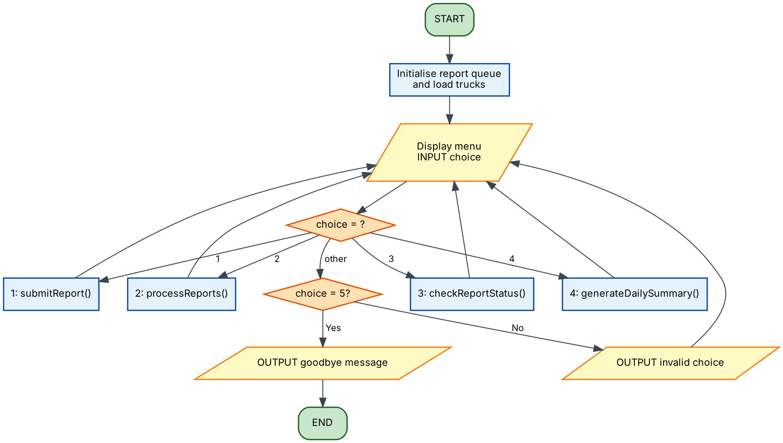
Figure 1: Main program with menu loop

4.2 Submit Report and Validation
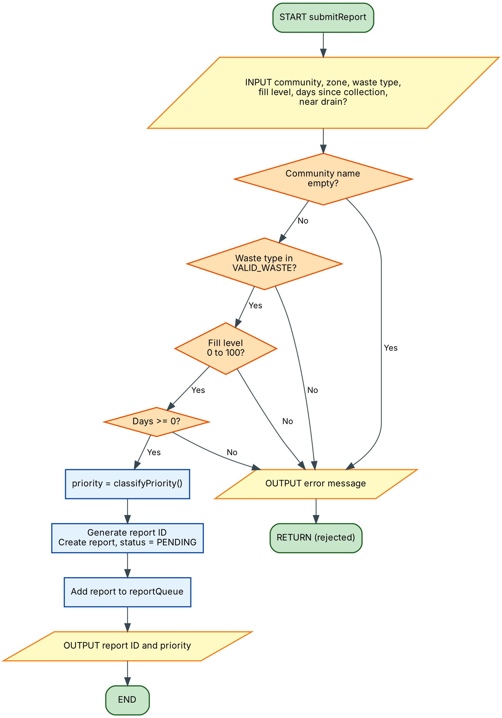
Figure 2: Submit report with input validation

4.3 Classify Priority
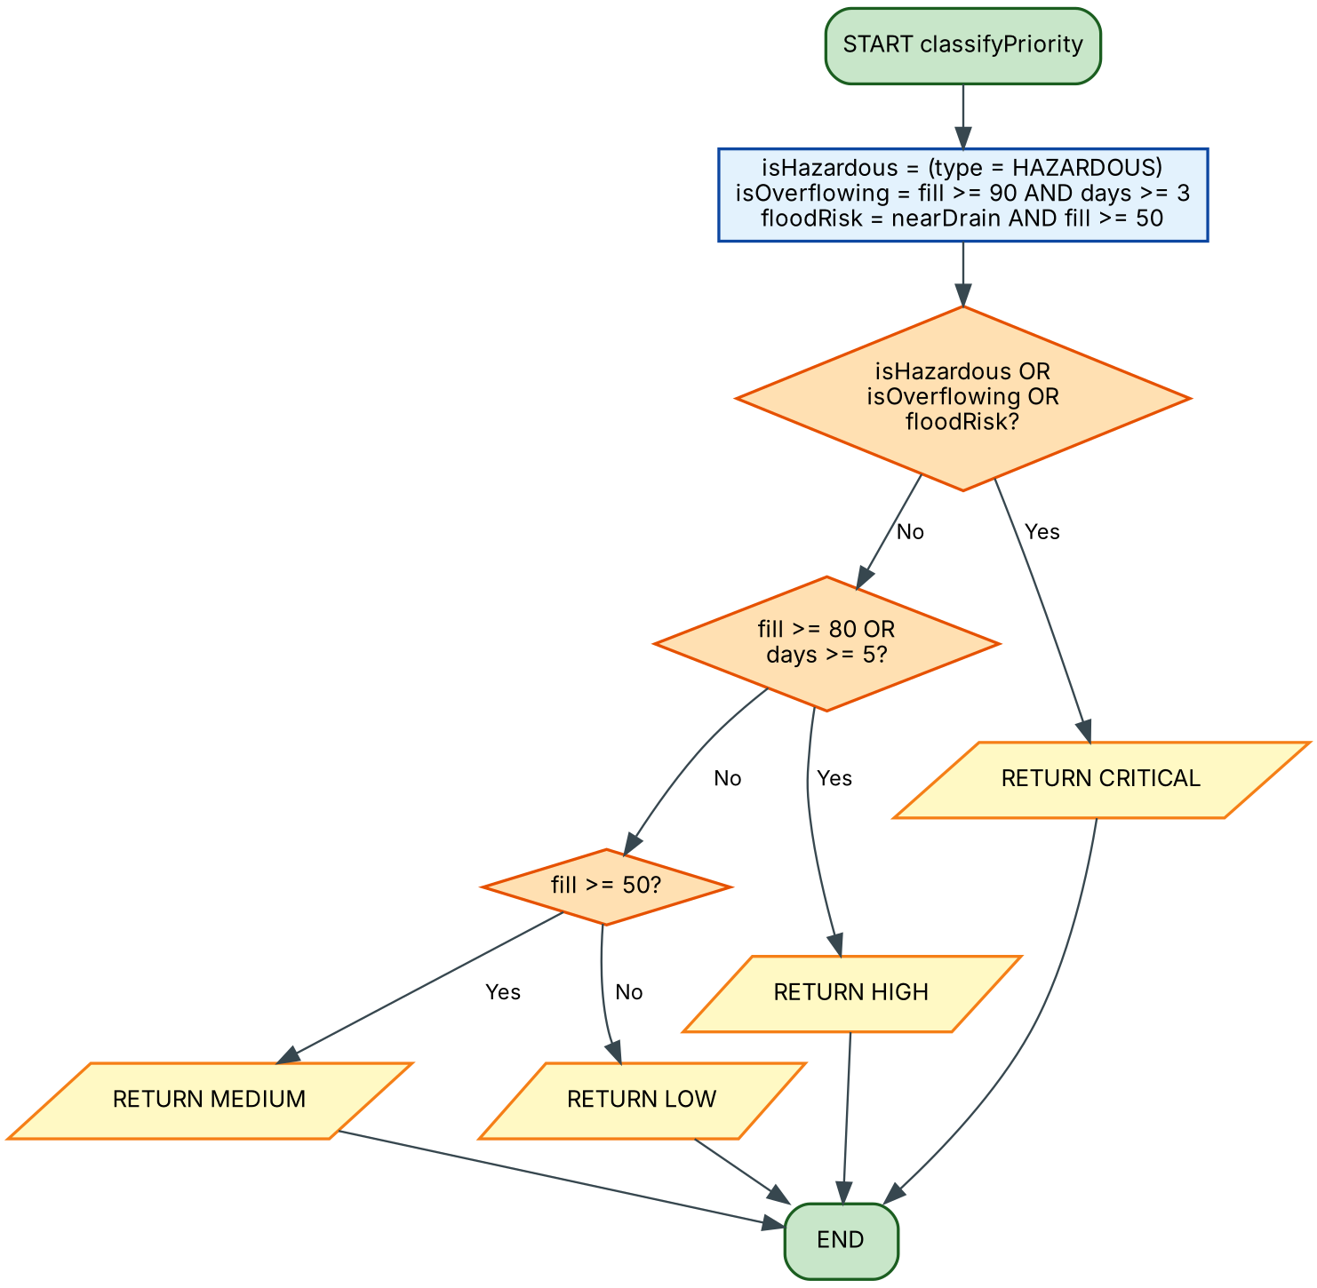
Figure 3: Priority classification using decision structures and Boolean logic

4.4 Process Reports and Dispatch Trucks
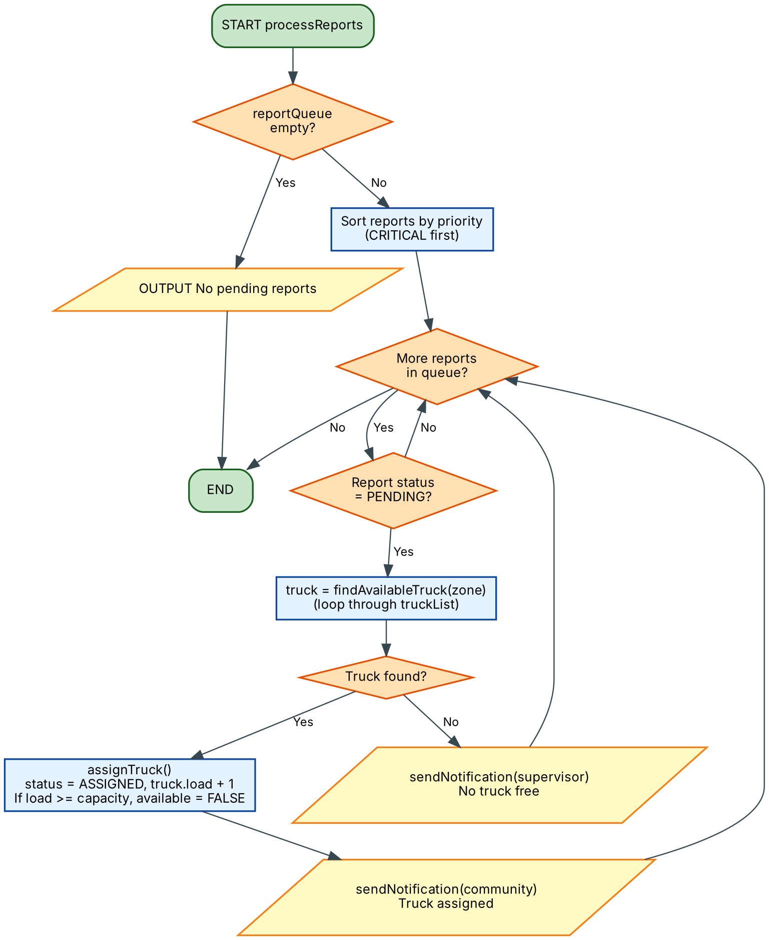
Figure 4: Dispatch loop over the report queue and truck list

4.5 Daily Summary
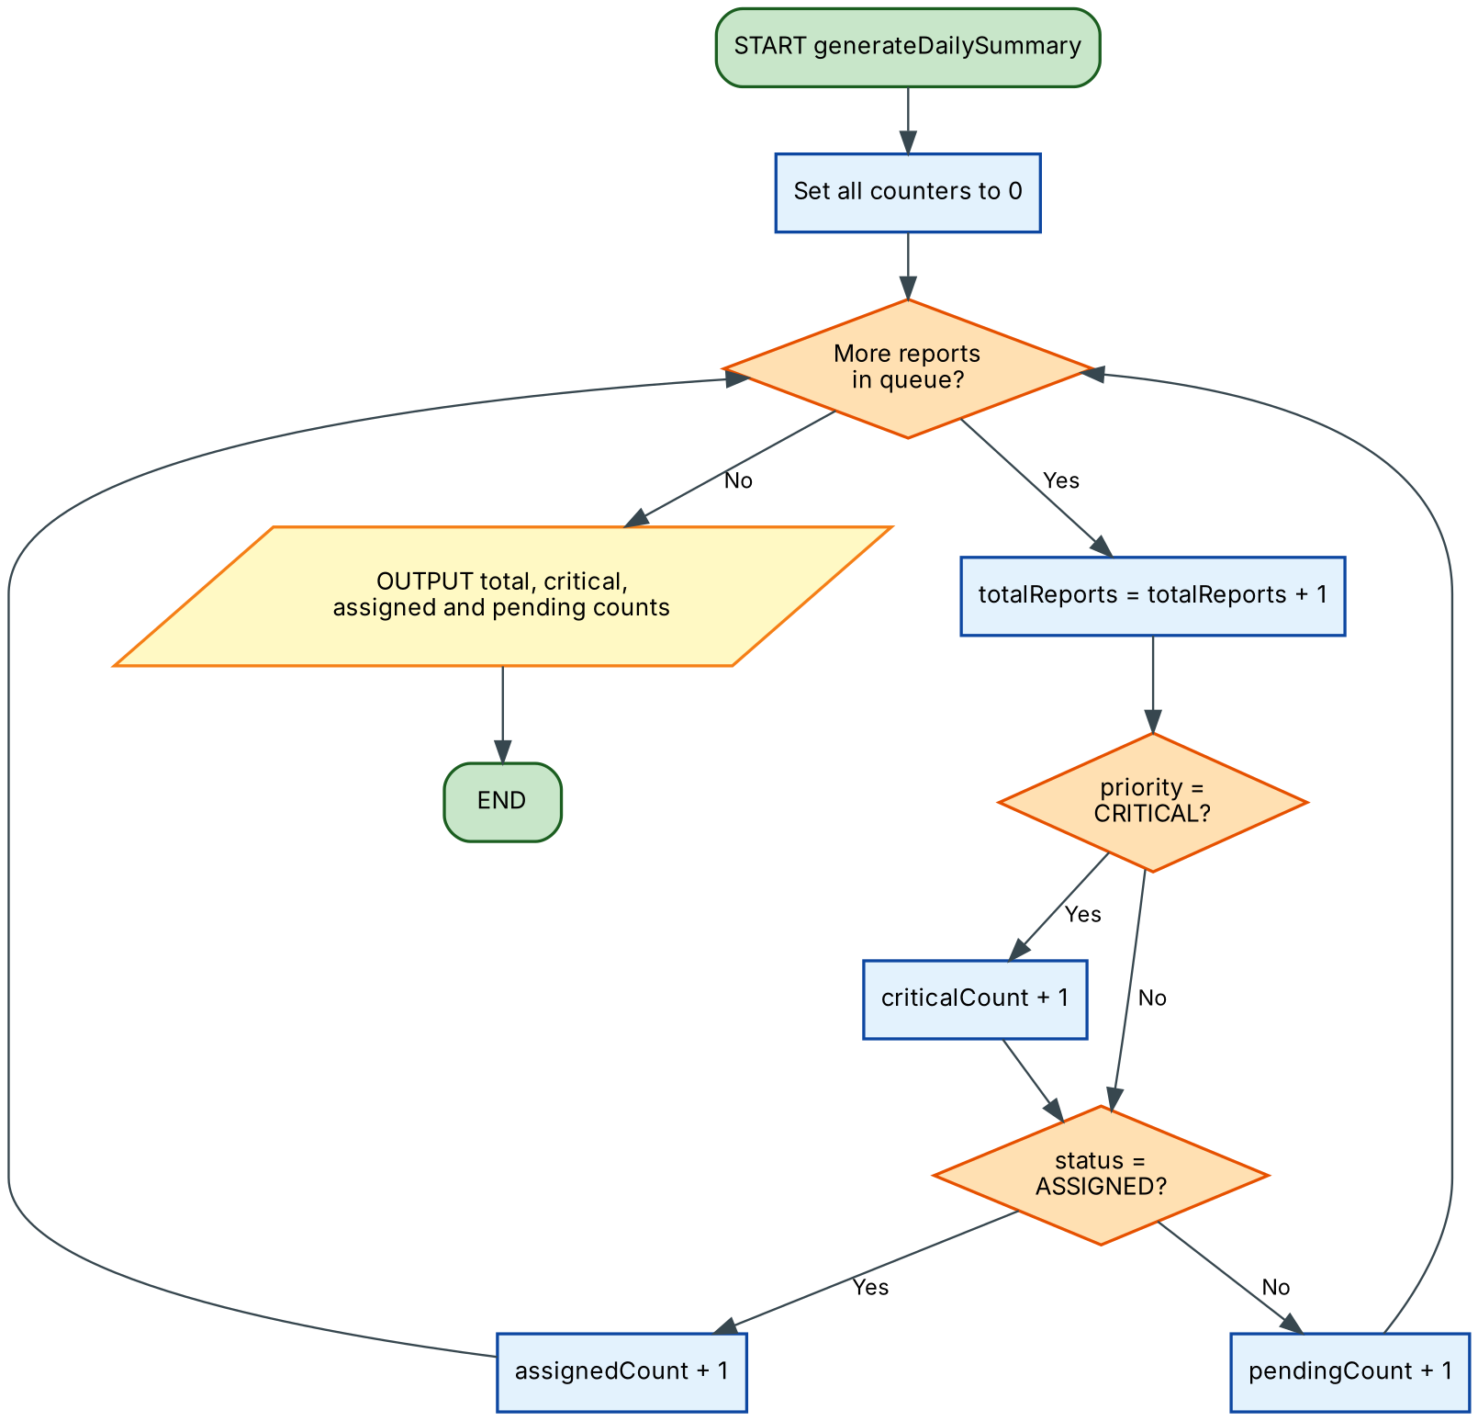
Figure 5: Daily summary with counters and a repetition structure

5. Functional Modules
Modular design and problem decomposition split CleanSalone into independent functions. Each does one job, which makes the system easier to test, explain and extend.
Module / Function | Input | Processing | Output
main() | Menu choice | Loops until choice = 5 and calls the modules by decision (IF / ELSE IF) | Menu, goodbye message
submitReport() | Community, zone, waste type, fill, days, near drain | Calls validateReport(), classifyPriority(), creates report with ID | Report ID, priority
validateReport() | Name, type, fill, days | Four decision checks | TRUE / FALSE and error text
classifyPriority() | Type, fill, days, drain flag | Boolean logic with AND, OR; nested IF | CRITICAL / HIGH / MEDIUM / LOW
processReports() | Report queue, truck list | Sort; FOR EACH loop; calls findAvailableTruck() and assignTruck() | Assignments, notifications
findAvailableTruck() | Zone | Loop through trucks and test zone, availability, load | Truck or NULL
checkReportStatus() | Report ID | Search loop with found flag | Community, priority, status
generateDailySummary() | Report queue | Loop with counters | Totals

5.1 Constants
Constant | Value | Purpose
FULL_THRESHOLD | 80 | Fill percentage at which a bin counts as full
CRITICAL_FILL | 90 | Fill percentage treated as overflowing
MEDIUM_FILL | 50 | Lower bound for medium priority and flood-risk check
URGENT_DAYS | 5 | Days without collection that raise priority to HIGH
OVERFLOW_DAYS | 3 | Days used with CRITICAL_FILL for overflow
MIN_FILL / MAX_FILL | 0 / 100 | Valid range for fill level
TRUCK_CAPACITY | 10 | Maximum collection points per truck per day
VALID_WASTE | List | GENERAL, PLASTIC, ORGANIC, HAZARDOUS

5.2 Variables and Data Types
Variable | Data Type | Description
reportID | Integer | Unique number for each report
communityName, zone, wasteType | String | Location and type of waste
fillLevel, daysSinceLast | Integer | Bin fill percentage; days since last collection
nearDrain, isValid, isHazardous, isOverflowing, floodRisk | Boolean | True/False conditions used in decisions
priority, status | String | CRITICAL/HIGH/MEDIUM/LOW; PENDING/ASSIGNED
reportQueue, truckList | List (array of records) | Stores reports and trucks
totalReports, criticalCount, assignedCount, pendingCount | Integer | Counters for the summary

5.3 Programming Logic Coverage
Requirement | Where it is demonstrated
Computational thinking | Section 1.5
Algorithm design | Section 2
Variables, constants, data types | Sections 3, 5.1 and 5.2
Decision structures | validateReport(), classifyPriority(), main() menu
Boolean logic | classifyPriority(): isHazardous OR isOverflowing OR floodRisk
Repetition structures | main() WHILE loop; FOR EACH loops in dispatch, search and summary
Functions and modular design | Eight functions in Section 5
Problem decomposition | Section 1.5 and the module table above

6. Expected Outputs
The following sample scenarios show what the design should produce. Trucks T01 and T02 cover zone WEST-1 and truck T03 covers EAST-1 in the examples.
No. | Input | Logic applied | Expected output
1 | Kroo Bay, WEST-1, GENERAL, fill 95, 4 days, near drain = Yes | isOverflowing = TRUE and floodRisk = TRUE | Priority CRITICAL. Truck T01 assigned.
2 | Wellington, EAST-1, PLASTIC, fill 60, 1 day, near drain = No | Not critical; fill < 80, days < 5; fill >= 50 | Priority MEDIUM. Truck T03 assigned after higher priorities.
3 | Lumley, WEST-1, ORGANIC, fill 130, 2 days | Fill > MAX_FILL | Error: fill level must be between 0 and 100. Report rejected.
4 | Connaught Hospital area, WEST-1, HAZARDOUS, fill 40, 0 days | isHazardous = TRUE | Priority CRITICAL. Truck assigned first.
5 | Mile 91, NORTH-1, GENERAL, fill 85, 2 days; no truck in zone | fill >= 80 so HIGH; findAvailableTruck() returns NULL | Priority HIGH. Supervisor notified: no truck free.
6 | Menu choice = 9 | No valid option | Invalid choice. Enter a number from 1 to 5.

6.1 Sample Console Output
=== CLEANSALONE MENU ===
1. Submit report 2. Process reports 3. Check status
4. Daily summary 5. Exit
Enter choice: 1
Report received. ID: 1001 Priority: CRITICAL
Enter choice: 1
Error: fill level must be between 0 and 100.
Report rejected: please correct the details and try again.
Enter choice: 2
Report 1001 -> Truck T01 assigned (Kroo Bay)
Report 1004 -> Truck T02 assigned (Connaught Hospital area)
No truck free for report 1005
Enter choice: 4
Total reports : 5
Critical : 2
Assigned : 4
Pending : 1

7. GitHub Evidence
The project was version-controlled in a Git repository named PROG101_Assignment1_RhodaYMansaray_905006427, following the required naming convention PROG101_Assignment1_StudentName_StudentID. The evidence below was captured from that repository on 3 November 2026.
Evidence item | Details
Repository name | PROG101_Assignment1_RhodaYMansaray_905006427
Branch | main
Commits at capture | 9 commits, each adding one part of the project
Files | README.md, pseudocode.txt, docs/ (5 Markdown files), flowcharts/ (5 PNG files and 5 Graphviz .dot sources)
Evidence included | Commit history (Figure 6), repository file structure (Figure 7), rendered README.md (Figure 8)

7.1 Commit History
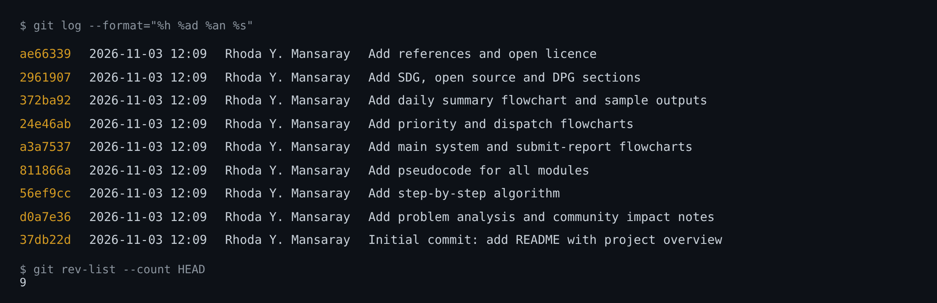
Figure 6: Git commit history of the repository (9 commits)

7.2 Repository File Structure
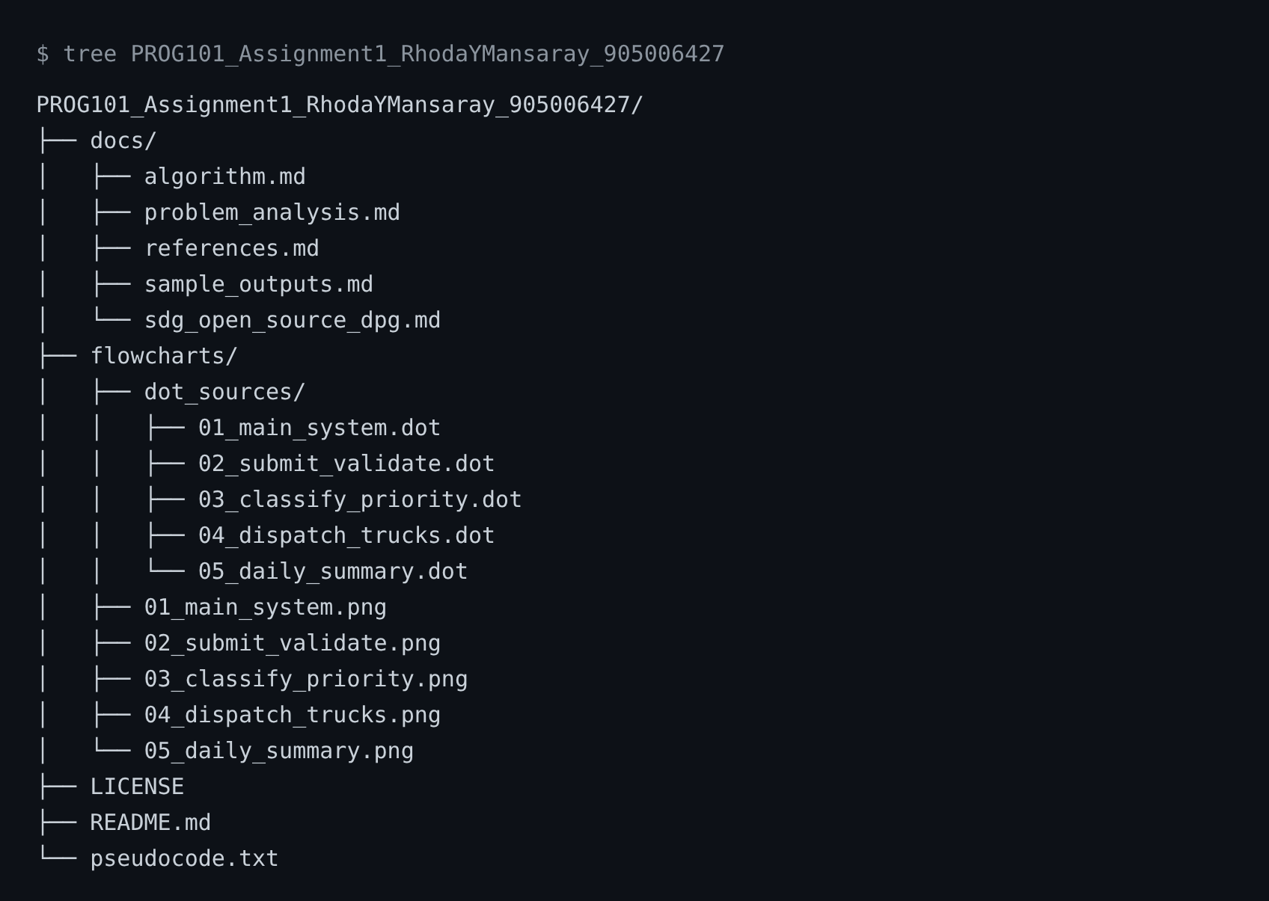
Figure 7: Repository file structure

7.3 Rendered README.md
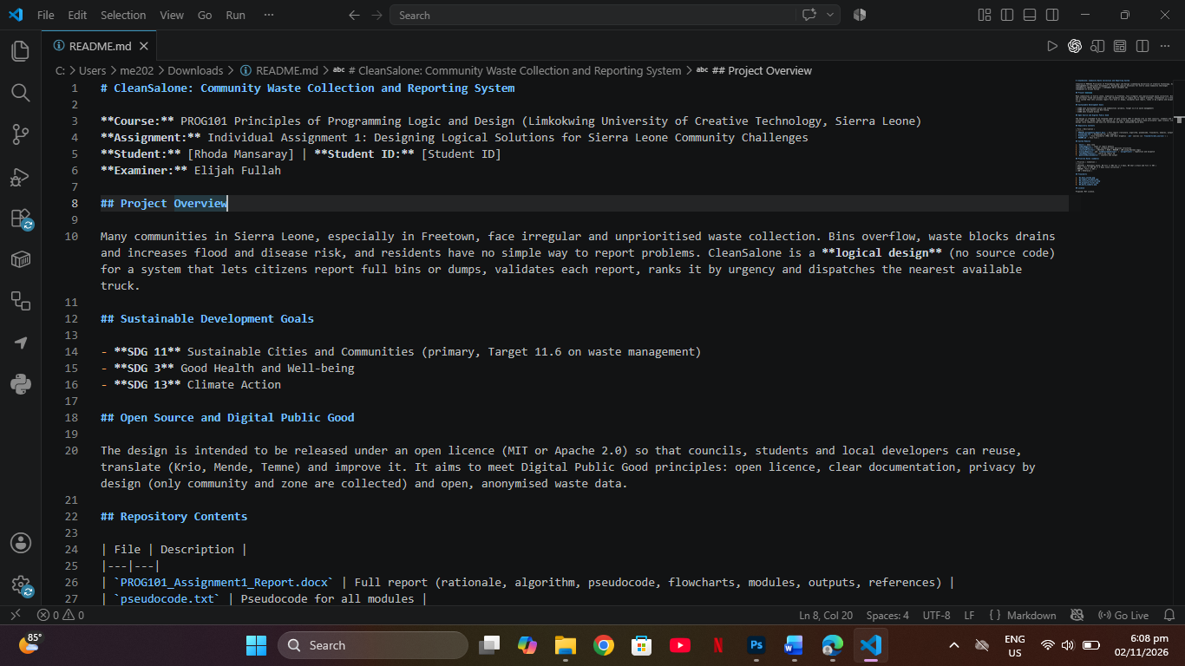
Figure 8: README.md as rendered on the repository front page

8. References
ACAPS (2017) Briefing Note: Sierra Leone: Mudslides and floods, 16 August 2017. Available at: https://www.acaps.org/sites/acaps/files/products/files/20170816_acaps_start_briefing_note_sierra_leone_mudslides_and_floods.pdf (Accessed: 3 November 2026).
Digital Public Goods Alliance (n.d.) The DPG Standard. Available at: https://www.digitalpublicgoods.net/standard (Accessed: 3 November 2026).
Git (n.d.) Pro Git book. Available at: https://git-scm.com/book/en/v2 (Accessed: 3 November 2026).
GitHub (n.d.) About the repository README file. Available at: https://docs.github.com/en/repositories/managing-your-repositorys-settings-and-features/customizing-your-repository/about-readmes (Accessed: 3 November 2026).
GSMA (n.d.) Freetown Waste Transformers (FWT) secures major waste collection concession from Freetown City Council. Available at: https://www.gsma.com/solutions-and-impact/connectivity-for-good/mobile-for-development/blog/freetown-waste-transformers-ftw-secures-major-waste-collection-concession-from-freetown-city-council/ (Accessed: 3 November 2026).
Limkokwing University of Creative Technology (2026) PROG101 Assignment 1: Designing Logical Solutions for Sierra Leone Community Challenges. Freetown: Department of ICT.
Open Source Initiative (n.d.) What is Open Source? Available at: https://opensource.org/education/what-is-open-source (Accessed: 3 November 2026).
United Nations (n.d.) Goal 11: Make cities and human settlements inclusive, safe, resilient and sustainable. Available at: https://sdgs.un.org/goals/goal11 (Accessed: 3 November 2026).

Appendix A: README.md (Repository Front Page)
This is the content of README.md as it appears on the front page of the GitHub repository.
Course: PROG101 Principles of Programming Logic and Design (Limkokwing University of Creative Technology, Sierra Leone)
Assignment: Individual Assignment 1: Designing Logical Solutions for Sierra Leone Community Challenges
Student: Rhoda Y. Mansaray | Student ID: 905006427

Project Overview
Many communities in Sierra Leone, especially in Freetown, face irregular and unprioritised waste collection. Bins overflow, waste blocks drains and increases flood and disease risk, and residents have no simple way to report problems. CleanSalone is a logical design (no source code) for a system that lets citizens report full bins or dumps, validates each report, ranks it by urgency and dispatches the nearest available truck.

Sustainable Development Goals
- SDG 11 Sustainable Cities and Communities (primary, Target 11.6 on waste management)
- SDG 3 Good Health and Well-being
- SDG 13 Climate Action

Open Source and Digital Public Good
The design is intended to be released under an open licence (MIT or Apache 2.0) so that councils, students and local developers can reuse, translate (Krio, Mende, Temne) and improve it. It aims to meet Digital Public Good principles: open licence, clear documentation, privacy by design (only community and zone are collected) and open, anonymised waste data.

Repository Contents
File | Description
PROG101_Assignment1_Report.docx | Full report (rationale, algorithm, pseudocode, flowcharts, modules, outputs, references)
pseudocode.txt | Pseudocode for all modules
flowcharts/ | Five flowcharts (PNG) and their Graphviz .dot sources (in flowcharts/dot_sources/)
README.md | This file

System Modules
- main(): menu loop
- submitReport(): input of report details
- validateReport(): input validation with decision structures
- classifyPriority(): CRITICAL / HIGH / MEDIUM / LOW using Boolean logic
- processReports() and findAvailableTruck() / assignTruck(): repetition and dispatch
- checkReportStatus(): search by report ID
- generateDailySummary(): counters and output

Priority Rules (summary)
Priority | Condition
CRITICAL | Hazardous waste, OR fill >= 90% for >= 3 days, OR near a drain and fill >= 50%
HIGH | Fill >= 80% OR >= 5 days since collection
MEDIUM | Fill >= 50%
LOW | Otherwise

